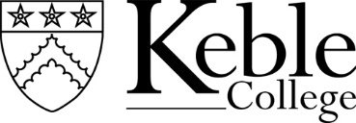

Person Specification - Lodge / Reception Manager

Essential:
- Previous management experience with responsibility for a team
- Calm and able to deal confidently with emergency or challenging situations
- Energetic, good humoured with a passion for quality service
- Proven track record of problem-solving and making things happen
- Experience in a front-line customer related situation
- Conversational level spoken English
- Excellence in own and team’s presentation: attention to detail and a passion for providing excellent customer service
- Computer literacy: Intermediate level Word, Excel, Outlook and knowledge of booking systems
- Self-motivated and able to take decisions after consideration of options
- Able to successfully balance formality and informality and possess the ability to communicate clearly and deal confidently with a diverse range of people
- Team working skills and a willingness to support and assist colleagues when required including a flexible approach to work and duties and ability to change working hours if required to cover for colleagues

Desirable:
Experience of:
• working in a Hospitality environment
• reviewing and devising SOP’s
• planning and delivering of change within a team
- managing and devising shift rosters and maximising staff efficiency (including external contractors/temporary workers)

Terms and Conditions
- Salary: £42,406 p.a.
- Healthcare: college-paid premium for private healthcare scheme
- Team’s work hours cover shifts from 7am to 10pm on rotating basis (mixture of early and late shifts). This position is expected to work 37.5hrs to cover core hours
- Free lunch on duty when College meals are available
- College Gym membership (c.£95/yr)
- 38 days holiday (includes public holidays)
- Eligible for membership Universities Superannuation Pension Scheme
- Must become and remain first aid qualified

7.11.25

