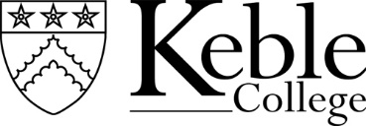

PERSON SPECIFICATION

Maintenance Administrator

Essential

- Possess at least 2 years demonstratable experience in administration
- Have practical and demonstrable Microsoft skills, e.g. Word, Excel, and Outlook, as well as database inputting and reporting
- Have excellent interpersonal skills with the ability to communicate with all levels - written and oral
- Highly organised and efficient
- Have the ability to organise own workload with minimal direction and manage time effectively
- Have good judgment about when to use initiative and when to consult
- Ability to juggle priorities and has effective coping strategies
- Outgoing and resilient and responds positively to change, ambiguity, adversity and pressure

Desirable
- Knowledge of construction compliance and legislation or an understanding of property maintenance issues
- Demonstrable knowledge of relevant health and safety documentation
e.g. COSHH assessments, method statements and risk assessments
- Understanding of the General Data Protection Regulations

November 2023

